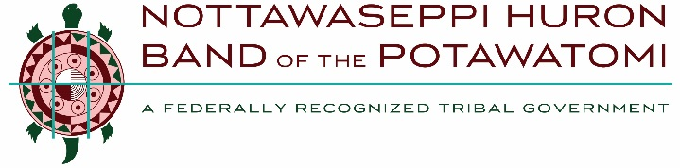

MNO BMADZEWEN • HEALTH AND HUMAN SERVICES
Behavioral Health Screening Form

Date of request for services: _____________

Who received the request: _______________

Client Name: __________________________

Screening Date: ______________________

Screening Staff: ______________________

Client Address: _______________________

Client Phone: __________________________ ____________________________________

Tribal Affiliation: ________________________ Insurance: ___________________________

Presenting Problem (why are they seeking services): Check as many as apply
relationship struggles addictions depression or anxiety mental health diagnoses
parenting concerns trauma or PTSD situational stressors family problems
individual problems suicide other: ______________________________________________________________________________________

Which location is preferred: Pine Creek Grand Rapids

Are there any urgent/emergency needs, such as suicide or homicidal behavior?
No Yes: _________________________________________________________________

Is the client a NHBP employee or a child of a NHBP employee? No Yes: _______________

_______________________________________________________________________________

Outcome of Screening: Scheduled Forwarded Ineligible for services due to: _______

_______________________________________________________________________________

Any additional information (include any parent/guardian name and phone) : _________________

_______________________________________________________________________________

NHBP Staff Use Only:
If any red boxes are checked, please forward to a Behavioral Health team member immediately.

1474 MNO- BMADZEWEN WAY • FULTON, Ml 49052
NOTTAWASEPPI HURON BAND OF THE POTAWATOMI

